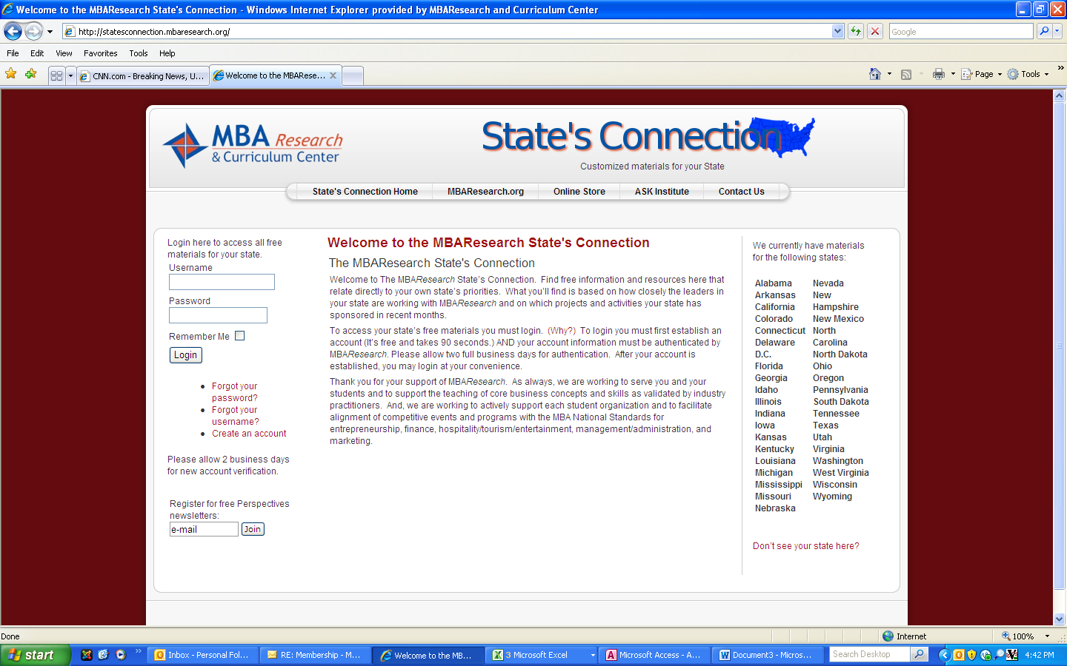
MBA Research State’s Connection
Free materials for ALL business and marketing teachers

State’s Connection is a benefit of your state’s membership in the
MBA Research Consortium of States

- State’s Connection is free to all teachers in all member states.
- Actual content varies by state and is based on state participation in various projects.
- FREE materials you’ll find in State’s Connection:
  - Program-of-Study Kits for: Entrepreneurship, Marketing, Finance and Business Management and Administration
  - www Bookmarks tied to standards
  - Course guides (13 different courses!)
  - Crosswalks
  - “Real-time” standards data base
  - Authentic assessment/Rubrics guide (new revisions in 15-16)
  - Curriculum Builder web-based software database: NEW course in 15 minutes
  - Action Briefs: Trends in business that matter to your curriculum

To access State’s Connection:
- Begin at the MBA Research home page (www.MBAResearch.org)
- Find the State Connection link in the Quick Links box on the left
- Go to the State’s Connection page and find the “Create an Account” link (left column)
- Registration takes TWO minutes; allow two business days for confirmation of your status
- Enjoy

MBAResearch
800.448.0398 x0 Service@MBAResearch.org

